Minutes of the PWG Web Based Monitoring and Management Face to Face

Washington, D.C.

April 22, 2004
Harry Lewis
04/28/04

Attendees
- Lee Farrell, Canon
- Harry Lewis, IBM
- Takanori Masui – FujiXerox
- Ira McDonald, High North
- Fumio Nagasaka – Epson
- Stuart Rowley – Kyocera Mita
- Jerry Thrasher, Lexmark
- Bill Wagner, NetSilicon
- Craig Whittle, Sharp Labs of America
- Peter Zehler, Xerox

General Discussion
We reviewed and accepted minutes from the March 31 conference call.

Bill reiterated that much of the recent work in WBMM has been focused on Counters. There was debate regarding the status of Operations and Actions, Harry asserting that these have been stable for some time (see previous minutes). We agreed that it is likely the full set of Operation and Actions are identified but the specification of some operands is not complete. Specifically, return values need to be defined for operations such as “RegisterForManagement” and “UnregisterForManagement”.

Background
Bill provided a background presentation and review of the WBMM Charter for those in attendance who might be unfamiliar.

Charter
Highlights
- Extra-enterprise monitoring and management
- Device and service management
- Management Model describing
  - Transport (SOAP)
  - Protocol (Operations, Actions and Responses)
  - XML schema
    - Aligned with and/or extending the PWG Semantic Model
    - Derived from existing management related SNMP MIBs where appropriate

Initial Targets
- WD Q1 2004
- CS Q2 2004
- Interop Q3 2004
- Standard Q4 2004

Accomplishments
- Charter – June 2003
- Use Cases – August 2003
- Definitions Draft – August 2003
- Spec Draft – January 2004
- Printer Management Schema – Feb 2004
- Counter MIB – Apr 2004
- MFP Schema – (on hold, will reexamine as we work with DMTF CIM)

Interfaces
We reviewed the interface diagram from the WBMM Working Draft and there was comment that the interface naming is too vague. The following changes were proposed and agreed upon:

“Managed Entity Interface” will change to “Agent Interface”
“Management Station Interface” will change to “Management Interface”
Note: or was this “Manager Interface”, or did we not agree?

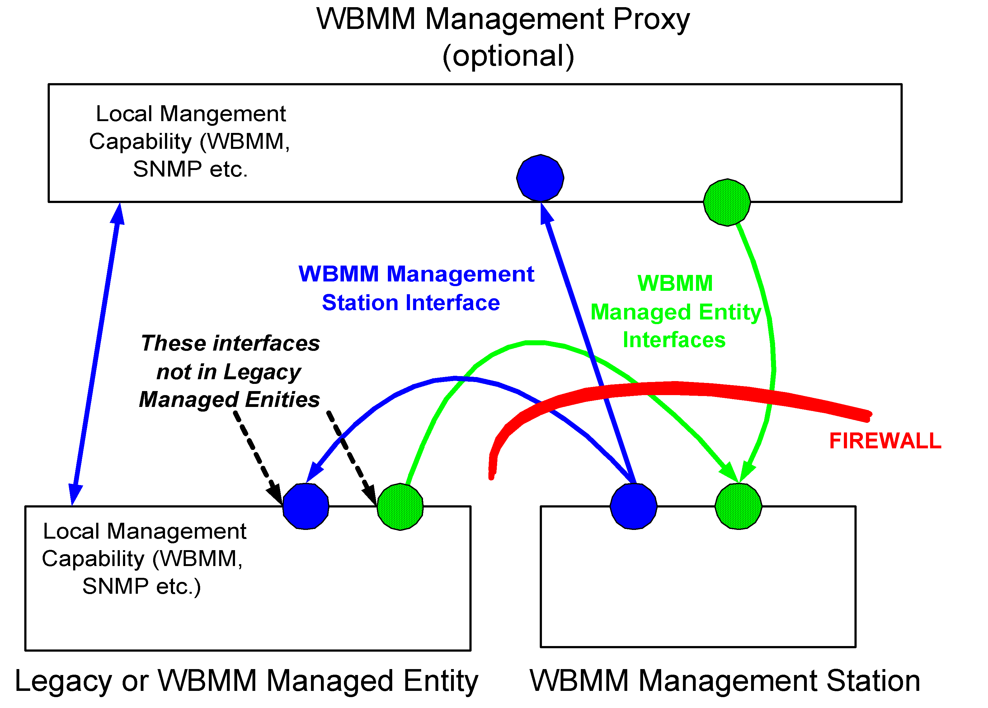

Eventing
Worked on event names standard and event schema.

IPP base notification spec has series of standard events for printers and for jobs
Schema created with all these events abstracted and generalized to any service we are likely to encounter in the MFP (ex. not just printers).
For each new schema generated we need a spec because schema are not formal documents.

If we want to extend our lists we need an aux registry in the PWG. Wherever we are extending current Printer MIB OIDs, and we want these to be accessible via the Printer MIB, we must also register these with IANA. As we extend events to MFP functionality, these will come under complete PWG control.
Ira plans on producing a spec for events. This is also related to PSI.
Attempt to get ready for next (May – Vancouver) f2f.

MISC
Is a MFP management structure a worthwhile thing to do?
Scan job is always “scan-to-store”. Later sending scan to e-mail, fax etc is another action. So “scan-to-e-mail” is a compound job (not visible to the end-user).
We reviewed PSI request for WBMM management.
Some issues about Key exchange etc.

The name WBMM was too close to WBEM. We changed the name to WIMS (Web Imaging Management Services). Needed, especially as we take our work to DMTF.

Tried to go back through the Charter and modifying it for WIMS…thus expanding the original WBMM charter.

Counter MIB
Detailed walk through Counter MIB. Ira collected recommended changes and will republish.

Review of Operations and Actions
We reviewed Ops and Actions
Need to add Op responses (ex. Registration)
Clarify “Passive Mode” – agent in devices (or proxy) are administratively configured to contact management application outside firewall
“Active Mode” – management application initiates

Need WSDL for the ops

TO DO:
- Update of Counter Table and diagram of relationship between counters – Pete
- Counter Spec and SM update – Pete
- Counter MIB reordering – Ira
  - Improve documentation of icMediaUsedInfo
- Every vendor to check their products for semantic alignment – Bill to send msg
- PWG standard event names spec – Ira / Bill
- Multifunction imaging system model white paper – Ira
- Update spec, adding returns – Ira
- Naming of interfaces and actors - Bill

Next Conference Call
The next WBMM conference call will be in 1 week.

Time: Noon Eastern (9am Pacific) April 28, 2004
Call-in US Toll-free: 1-877-874-5524
Call-in International/Toll: 1-712-455-8420
Participant Identification number: 497478

