Harry, here is the info about hotels around the Austin area that give Dell rates.

----------------------------------------------------
Meeting blah blah blah date blah blah blah
At Dell facilities, Austin, TX.

The meeting will be in the Technology Briefing Center in Building 3 on the Parmer South campus. The building address is: 701 E. Parmer Lane, Building 3 (Parmer South 3), Austin, TX 78753

Recommended nearby hotels with Dell corporate discount rates.

Map of hotel locations. Several hotels are very near the meeting site, as you can see. The Round Rock hotels are a lot closer to the meeting site than the downtown hotels are, at least in driving time.

Map of Parmer South campus. The Technology Briefing Center is just off the lobby, which is in the link between buildings 2 and 3. There are visitor parking spaces right in front.

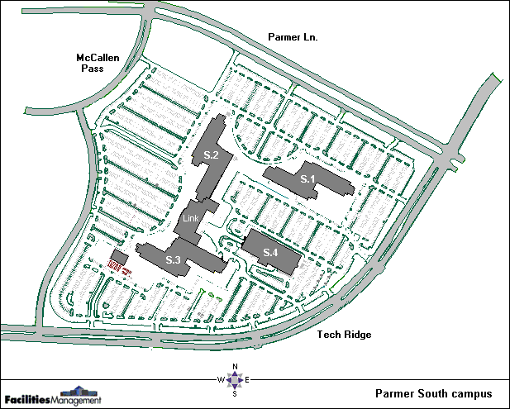

Map of relative locations of Austin-Bergstrom airport (AUS) and the Dell facilities.

